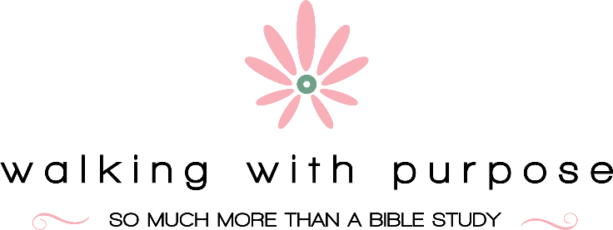 SAINT LUKE PARISH

Our Mission
Walking with Purpose aims to bring women to a deeper personal relationship with Jesus Christ by offering personal study and small group discussion that link our everyday challenges and struggles with the solutions given to us through the teachings of Christ and the Roman Catholic Church.

What is Walking with Purpose? Walking with Purpose is a women's Catholic Bible Study based in our Saint Luke Parish in McLean, Virginia. We offer both in person and virtual Zoom sessions to fit into your busy schedules

I am worried I will not know enough about the Bible. WWP is a Catholic Bible Study that meets each woman exactly where she is. You will do some self-study at home with the materials you are given, read scripture and participate in small group discussions once a week either in the parish hall or via Zoom. No one is a Bible scholar and no one is judged or expected to memorize or recite. It is a common journey of faith and fellowship.
Do you have to share within the group? I won’t know the women. One of the things most women mention first when describing WWP is the new friends and relationships they form as they share Scripture. The small group creates an atmosphere of trust, solidarity and inspiration. No one is forced to share, but as your comfort level increases week by week, you may be happy and excited to share your thoughts.

Every week is a big commitment. Do I need to come each week?

Most women have very little “white space” in their calendars. God speaks in the silence of prayer and meditation. View each weekly meeting as a gift to yourself - a gift of time...time to regroup and grow and be with women who enjoy fellowship and small group study. Consistency is important, however. All of us miss a week here and there due to family, work and personal commitments. Most women involved in WWP will tell you that their WWP group time is their favorite time of the week.

I haven’t practiced my faith or attended Mass in quite a while. No one will be questioning you. We are all at different places in our faith journey. Your privacy will always be respected. Start by joining today and take it one week at a time.
May I try a class first before I register? The doors of Walking with Purpose are always open to come and visit. You may participate in a class and sit in with any group anytime. You are also most welcome to join us once a month when we offer a Connect Coffee/ Open House which features a spiritually inspiring speaker and extended fellowship time to connect with other women of the community.

What materials will I need in order to participate in Walking with Purpose?

When you register for Walking with Purpose, the Welcome Team will give you all your study materials. If you are participating in a Zoom session, dates, times and places will be provided to you for pickup of materials.

When does the program begin and end?

Our courses run during the academic year, excluding school holidays. The exact dates are listed on the Registration Form and also on the calendars linked to this St. Luke website page for WWP.

How do I get more information about registering?

Just email: WalkingwithPurposeSaintLuke@gmail.com or WalkingWithPurpose.com

